**UNIT 4 REVISION – LETTERS AND NUMBERS**

**Exercise 1: Trace and write the numbers.**



**Exercise 2: Count and trace the correct numbers.**

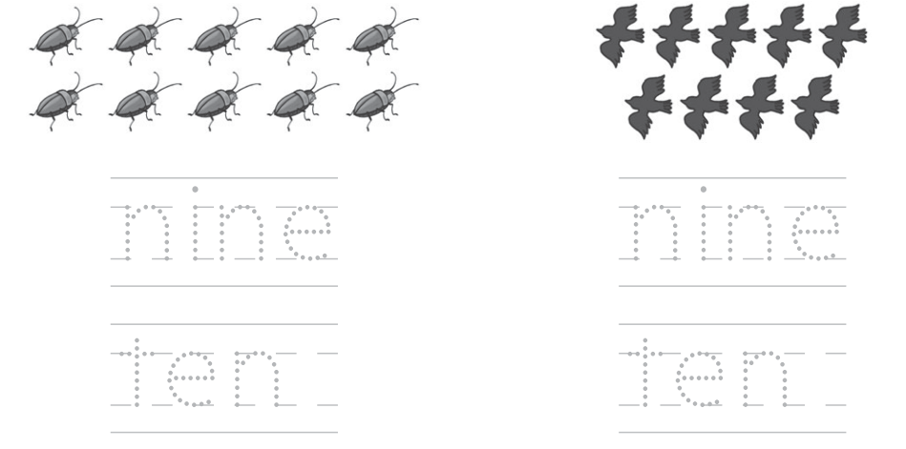

**Exercise 3: Trace and match.**



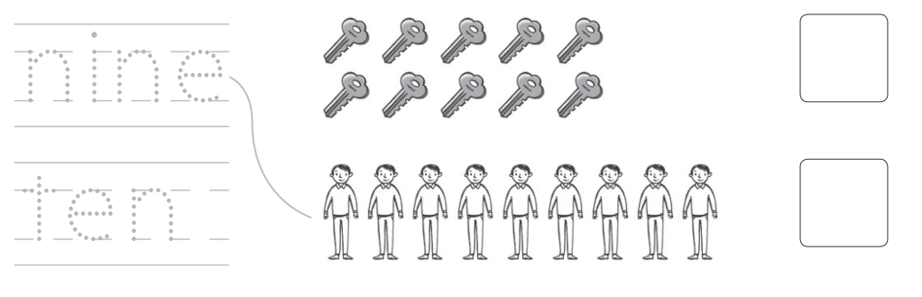

**Exercise 4: Trace and write the letters.**

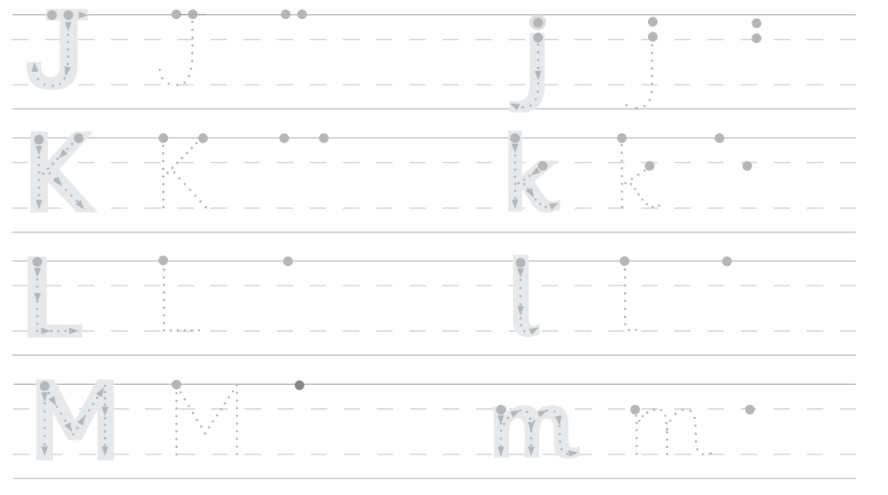

**Exercise 5: Trace the words and say.**

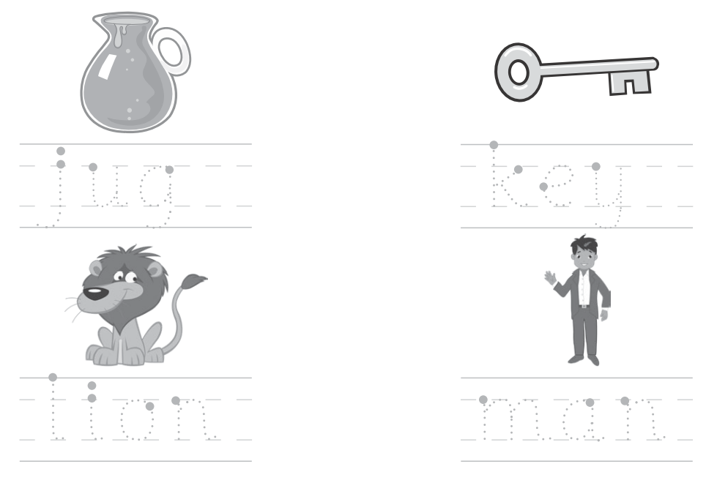

**Exercise 6: Look. Check (✓) or cross (🗶)**

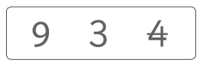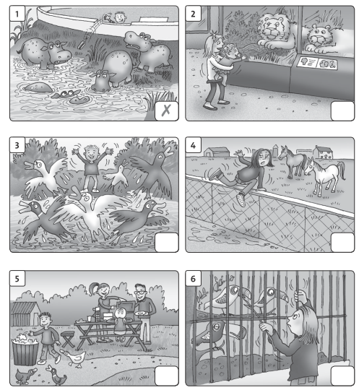

**Exercise 7: Count the animals and write the number.**



**Exercise 8: Look and match.**

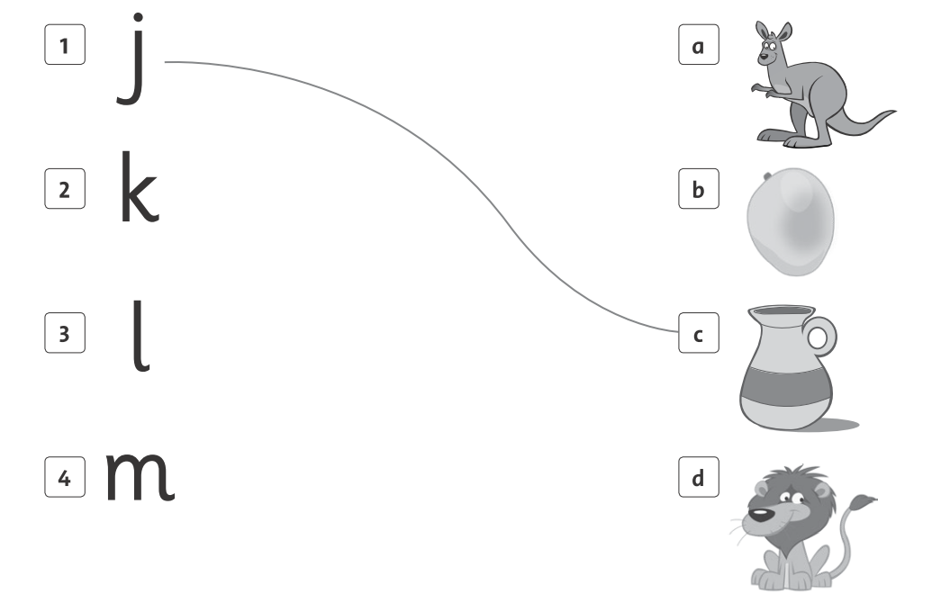

**Exercise 9: Look and circle the right pictures.**

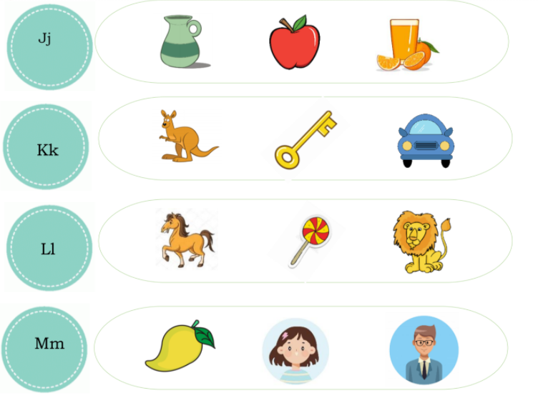

**Exercise 10: Count and choose the correct answer.**

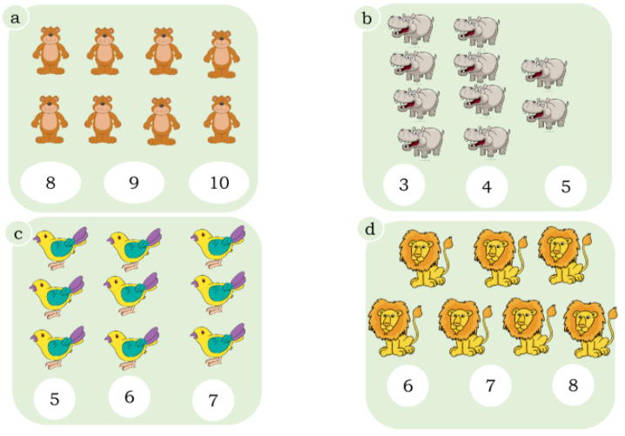

**Exercise 11: Count and write.**

